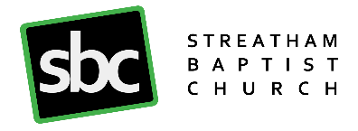

STATEMENT OF FAITH
We Believe:
- In the Triune God, Father, Son and Holy Spirit, Ruler, Creator and Sustainer of the Universe.
- In the divine inspiration of the Holy Scriptures and their supreme authority in all matters of faith and conduct.
- That all mankind is sinful and thus subject to the judgment of God.
- That eternal life is the free gift of God through faith in our Lord Jesus Christ, the incarnate Son of God, who died to pay for our sins, rose from the dead, ascended into heaven and is alive for evermore.
- That all true believers, regenerated and indwelt by the Holy Spirit together form the universal Church of which Christ is the head and source of life. That all such believers are chosen, created and called of God, to be the visible presence on earth of the living Christ, and are commended by God to love and to serve Him and one another and to preach the Gospel throughout the world.
- In the personal, visible return of our Lord Jesus Christ, the final judgment and the eternal kingdom of God.

Streatham Baptist Church is a member of the Baptist Union of Great Britain and supports its Declaration of Principle:
The Basis of the Baptist Union is:
- That our Lord and Saviour Jesus Christ, God manifest in the flesh, is the sole and absolute authority in all matters pertaining to faith and practice, as revealed in the Holy Scriptures, and that each Church has liberty, under the guidance of the Holy Spirit, to interpret and administer His laws.
- That Christian Baptism is the immersion in water into the Name of the Father, the Son, and the Holy Spirit, of those who have professed repentance towards God and faith in our Lord Jesus Christ who 'died for our sins according to the Scriptures; was buried, and rose again the third day'.
- That it is the duty of every disciple to bear personal witness to the Gospel of Jesus Christ, and to take part in the evangelisation of the world.

